**Relaxation Exercises**

Calm Body Strategy

Bend & Hang Stretch Breath

Stand up tall and raise your hands high above your head. Count to 5.

Bend over and let your arms hang down by your feet.

Try to loosen your arms and just let them hang.

Take 5 breaths and then slowly stand back up. Repeat 3 times.

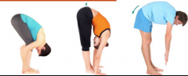

Calm Mind Strategy

Mindful awareness

Sit quietly and pay attention to your eyes blinking. How often do you blink. What does it feel like to blink. How often do you blink in one minute?

